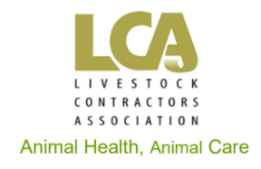

ESSENTIAL AGRICULTURAL WORKER

[insert business name] provides essential agricultural services in the livestock production industry.

[NSW ONLY PARAGRAPH – REMOVE IF NOT APPLICABLE ] In line with the NSW Government COVID-19 rules published by the NSW Department of Primary Industries on 12 August 2021, primary industry workers are exempt from stay-at-home orders.

[insert business name] workers are authorised to travel outside the local government area they live in when they are required to leave home for work related purposes. [PERMIT USERS ONLY PARAGRAPH – REMOVE IF NOT APPLICABLE -] Workers in [STATE] are also required to carry a [STATE GOVERNMENT NAME] permit.

This letter certifies that the below [insert business name] employee is required to travel for work-related purposes.

[e.g. Jane Smith]
[Address]
[Suburb/Town] [STATE] [post code]

[insert business name] is registered as a COVID safe business and has registered QR codes for full traceability on every contracted site.

OR

[insert business name] is registered as a COVID safe business and manually collects visitor and worker details for every work site.

[insert business name] owner and operator, [insert business owner’s name] can be contacted on [contact number] if further information is required. OPTIONAL IF NEEDED -> If it is urgent and [owner] cannot be reached, please contact [back up contact] on [back up person’s number].

[signature if possible, otherwise, just use the name field]

[business owner name]
[business name]
[business address]
[business email]

